Spectral coherence: AUDUSD and USDJPY
Method 21 / daily log returns / Welch magnitude-squared coherence / Alpari D1 full available history

Study setup
Logical pair: AUDUSD , USDJPY
Broker symbols: AUDUSD_i , USDJPY_i
Snapshot: 2026-11-03_majors_alpari_D1
Timeframe: D1
Matched return window: 1999-01-05 to 2026-11-02 (UTC bar dates)
Matched return count n: 7199
Dropped unfinished last bar dated 2026-11-03 UTC after a tick-volume check against the prior complete day.
Welch: fs=1.0, nperseg=256, noverlap=128, window=hann, detrend=constant
Headline: gamma^2 nearest f=1/5; also 1/21 and 1/63
Complete matched rows (Excel): AUDUSD-USDJPY_Spectral_D1.xlsx
Complete matched rows (HTML table): AUDUSD-USDJPY_Spectral_D1_data.html

Method carried forward
Magnitude-squared spectral coherence gamma^2(f) measures shared linear power between matched daily log returns of close, ln(close_t / close_t-1), at each frequency f (cycles per day). Quotes are not inverted. Welch settings are frozen: fs=1, nperseg=256, noverlap=128, window=hann, detrend=constant. Headline is gamma^2 at the frequency bin nearest f=1/5 (five-day cycle from the formula sheet). Also reported: gamma^2 nearest f=1/21 and f=1/63, mean gamma^2 over the frequency grid, and phase of the cross-spectrum at the 1/5 bin. Coherence is unsigned (0 to 1); phase carries timing. Same-sample Pearson r is a side check only. This is not causation and not a trading signal.

Results (headline)
gamma^2 near 1/5: 0.060073
bin f (1/5): 0.199219
phase at 1/5 (rad): 2.040487
gamma^2 near 1/21: 0.034529
gamma^2 near 1/63: 0.076238
mean gamma^2: 0.037372
Pearson r: -0.088151

Target-frequency summary
period | target_f | f_bin | gamma2 | phase_rad
5 | 0.2 | 0.19921875 | 0.06007347 | 2.0404872
21 | 0.04761905 | 0.046875 | 0.03452921 | -2.5816472
63 | 0.01587302 | 0.015625 | 0.07623756 | -2.9470808

Conclusion
Headline gamma^2 near f=1/5 for AUDUSD and USDJPY: 0.0601 (bin f=0.199219, phase=2.0405 rad). At ~1/21: 0.0345; at ~1/63: 0.0762. Mean gamma^2 = 0.0374. Pearson r = -0.0882. This is frequency-domain linkage, not a trading signal.

Charts
Daily closes

Daily log returns

Spectral coherence gamma^2(f)
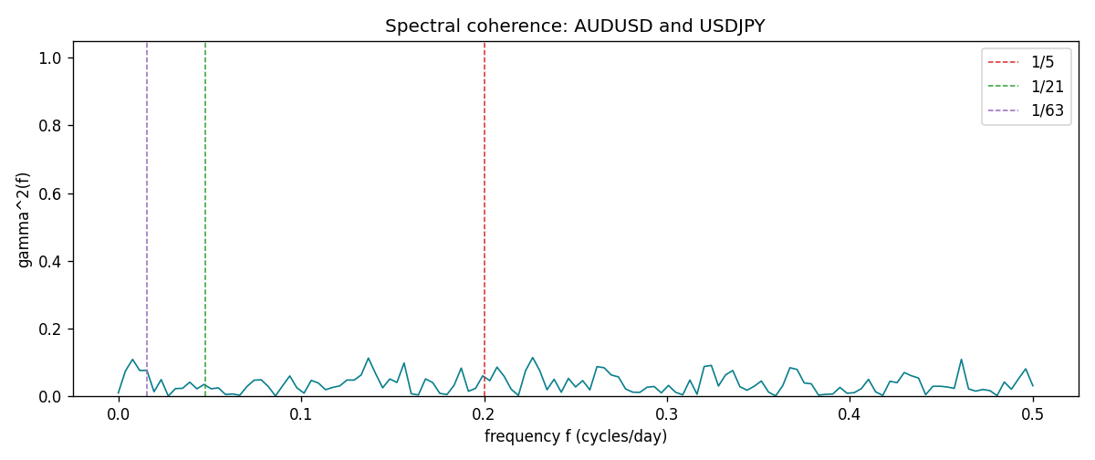

Data report
Matched rows and the coherence sheet are in the sibling Excel workbook named AUDUSD-USDJPY_Spectral_D1.xlsx. Embedding all rows as a Word table is impractical; this file holds column summaries and the first and last 15 matched rows.
Columns: time, AUDUSD_open, USDJPY_open, AUDUSD_high, USDJPY_high, AUDUSD_low, USDJPY_low, AUDUSD_close, USDJPY_close, AUDUSD_tick_volume, USDJPY_tick_volume, AUDUSD_spread, USDJPY_spread, AUDUSD_real_volume, USDJPY_real_volume, AUDUSD_log_return, USDJPY_log_return
Column summaries (matched calculation rows)
column | count | mean | std | min | 25% | 50% | 75% | max
AUDUSD_open | 7199 | 0.75196998 | 0.13527571 | 0.4785 | 0.661035 | 0.73142 | 0.809135 | 1.10284
USDJPY_open | 7199 | 113.81114 | 19.206896 | 75.693 | 104.4285 | 110.984 | 120.6925 | 163.824
AUDUSD_high | 7199 | 0.75602148 | 0.13583632 | 0.4878 | 0.6647 | 0.7349 | 0.815325 | 1.10795
USDJPY_high | 7199 | 114.30872 | 19.268446 | 76.001 | 104.881 | 111.442 | 121.26 | 163.978
AUDUSD_low | 7199 | 0.7479145 | 0.13459018 | 0.4775 | 0.6577 | 0.72758 | 0.80425 | 1.0975
USDJPY_low | 7199 | 113.28779 | 19.134887 | 75.402 | 103.89 | 110.53 | 120.17 | 163.628
AUDUSD_close | 7199 | 0.75202255 | 0.13525884 | 0.4786 | 0.661195 | 0.73175 | 0.809235 | 1.10169
USDJPY_close | 7199 | 113.824 | 19.222288 | 75.811 | 104.42 | 111.025 | 120.687 | 163.851
AUDUSD_tick_volume | 7199 | 77366.826 | 138149.99 | 109 | 5440 | 43349 | 71344.5 | 1234623
USDJPY_tick_volume | 7199 | 106151.62 | 179316.41 | 197 | 9927 | 53098 | 92761 | 1803508
AUDUSD_spread | 7199 | 30.814558 | 16.886804 | 0 | 13 | 30 | 50 | 50
USDJPY_spread | 7199 | 20.321434 | 17.631726 | 0 | 6 | 11 | 30 | 50
AUDUSD_real_volume | 7199 | 5.2435469e+09 | 1.2539788e+11 | 0 | 0 | 0 | 0 | 3.811512e+12
USDJPY_real_volume | 7199 | 3.470603e+10 | 1.6078743e+11 | 0 | 0 | 0 | 0 | 3.8834203e+12
AUDUSD_log_return | 7199 | 2.78e-05 | 0.00754502 | -0.08602525 | -0.00385397 | 0.00028846 | 0.00415332 | 0.0806166
USDJPY_log_return | 7199 | 4.761e-05 | 0.00620532 | -0.03908203 | -0.00320306 | 0.00011368 | 0.00340781 | 0.05184024
First 15 matched rows (selected columns)
time | AUDUSD_log_return | USDJPY_log_return
1999-01-05 | -0.00080418179 | -0.00017868311
1999-01-06 | 0.011836351 | 0.0075660159
1999-01-07 | 0.0088650256 | -0.012851583
1999-01-08 | 0.00031515916 | -0.0047719894
1999-01-11 | 0.0072213815 | -0.016195423
1999-01-12 | -0.0048608485 | 0.032310364
1999-01-13 | -0.0078902098 | 0.0081373171
1999-01-14 | -0.002696916 | 0
1999-01-15 | 0.007123101 | 0.0055343401
1999-01-18 | 0.00094592471 | 8.7600193e-05
1999-01-19 | 0.0072225153 | -0.0056219403
1999-01-20 | 0.0012507819 | -0.0053879917
1999-01-21 | 0.00078094498 | 0.0084664056
1999-01-22 | -0.012252745 | 0.0060412564
1999-01-25 | -0.0039591468 | -0.0073594164
Last 15 matched rows (selected columns)
time | AUDUSD_log_return | USDJPY_log_return
2026-10-13 | 0.0035007712 | -0.0018932826
2026-10-14 | -0.0015193215 | 7.5800166e-05
2026-10-15 | -0.0075447063 | -0.0018524319
2026-10-16 | 0.0033906408 | -0.00037976126
2026-10-19 | 0.0050859986 | 0.0034946841
2026-10-20 | 0.0034620426 | -0.0022546642
2026-10-21 | 0.0036066384 | -0.00032883504
2026-10-22 | -0.0012672558 | -0.0085942669
2026-10-23 | 0.0023765656 | 0.00035080446
2026-10-26 | -0.0032032829 | 0.0041238746
2026-10-27 | 0.0016669876 | 0.0027651658
2026-10-28 | 0.0040915541 | -0.00095679538
2026-10-29 | -0.0040915541 | -0.00038043789
2026-10-30 | 0.0010102376 | -0.0010596481
2026-11-02 | -0.0049184984 | 0.0026438521
First 15 frequency bins
f | gamma2 | phase_rad | period_days
0 | 0.00958853 | 3.1415927 | inf
0.00390625 | 0.07463999 | -1.640045 | 256
0.0078125 | 0.10877101 | -2.0526832 | 128
0.01171875 | 0.07593443 | -2.9330884 | 85.333333
0.015625 | 0.07623756 | -2.9470808 | 64
0.01953125 | 0.01315572 | -3.0983049 | 51.2
0.0234375 | 0.04900858 | 2.7212255 | 42.666667
0.02734375 | 0.00030347 | -1.9303634 | 36.571429
0.03125 | 0.02241375 | -2.8732866 | 32
0.03515625 | 0.02325671 | -2.9301096 | 28.444444
0.0390625 | 0.04134326 | 2.7562156 | 25.6
0.04296875 | 0.02173924 | -2.835393 | 23.272727
0.046875 | 0.03452921 | -2.5816472 | 21.333333
0.05078125 | 0.02174911 | -2.660199 | 19.692308
0.0546875 | 0.02465852 | -2.9682144 | 18.285714

